Difference of IPC between China, India, USA

Hardy Jiang

Chapman University

**Abstract**

I = PAT

Impact is a function of….

* Population
* Affluence (might be helpful to think about this in terms of consumption of resources)
* Technology (intensity of the resource consumption; what tools are used to consume resources)

Using the different population,energy consumption(Affluence) and Greenhouse Gas Emission(Technology) to display the impact per capita between China, India, USA. The impact per capita has exhibited varying trends across China, India, and the United States over the past two decades, focusing on the interplay between energy use and its implications for sustainability. Using historical data, the research examines trends in GHG emissions per capita, energy consumption per capita, and the ratio of emissions to energy use as a measure of impact efficiency. Key differences in energy production sources (renewable versus non-renewable) are explored, along with sectoral energy consumption patterns in residential, electricity generation, transportation, commercial and etc. domains.

Findings reveal these trends: while the U.S. exhibits relatively high but declining per capita emissions and energy use due to increased efficiency and renewable energy adoption, China has experienced rapid growth in both metrics, driven by industrial expansion and reliance on coal. India, with the lowest per capita values among the three, shows a steady upward trend due to urbanization and economic growth, though renewable energy adoption is accelerating. Comparative analysis highlights that China’s emissions intensity (GHG per unit energy) remains higher than the global average, whereas India demonstrates modest efficiency improvements. Per capita impacts at the individual level—calculated on daily and annual bases—underscore the disproportionate environmental burden in the U.S., despite progress in decarbonization, compared to China and India.

This study underscores the critical need for tailored policies to mitigate emissions while addressing energy demands. Accelerating the transition to renewable energy and improving energy-use efficiency in high-impact sectors is imperative for aligning global energy consumption with sustainability goals.

### **GHG Emission Per Capita Trends**

Over the last two decades, GHG emissions per capita have diverged significantly among China, India, and the United States, reflecting differing economic growth patterns, energy mixes, and policy implementations. In the United States, GHG emissions per capita have generally declined since the early 2000s, largely due to shifts from coal to natural gas and renewables, alongside energy efficiency improvements in industrial processes and residential sectors. However, despite a decrease in emissions, the U.S. remains one of the highest emitters per capita globally. In contrast, China has seen a dramatic rise in per capita emissions due to rapid industrialization and increased energy consumption, driven largely by coal reliance in power generation. India’s emissions per capita, while still among the lowest globally, have steadily increased as the nation grows economically and urbanizes, though its reliance on coal also contributes to growing emissions.

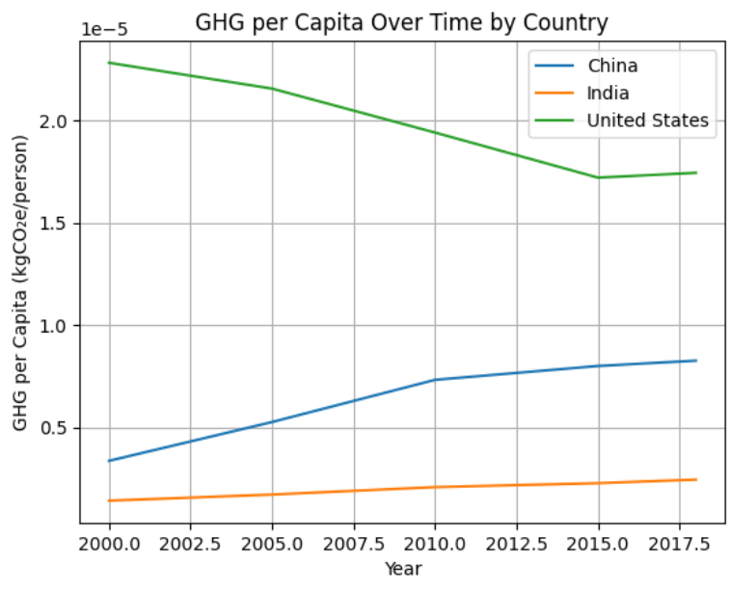

*(GHG emission per capita of China, Indian, United states from 2000 - 2018)*

[*Source Code*](https://colab.research.google.com/drive/1gJeoVK7hz4sJjB9efH154prVNM1Z-hN6?authuser=2#scrollTo=bjP7Mvm7lfNs)

### **Energy Consumption Per Capita Trends**

Energy consumption per capita has shown varied trends across the three countries. In the U.S., energy consumption per capita has remained relatively stable or slightly declined in recent years, driven by increased energy efficiency and the shift towards less energy-intensive industries. On the other hand, China’s per capita energy consumption has grown substantially due to its rapid industrialization, expanding infrastructure, and rising living standards. India’s energy consumption per capita remains much lower compared to China and the U.S., but it has been steadily increasing as the economy develops, with growth particularly evident in sectors like transportation and residential energy use. The differences in energy consumption per capita reflect the differing stages of development and the adoption of energy-saving technologies across these countries.

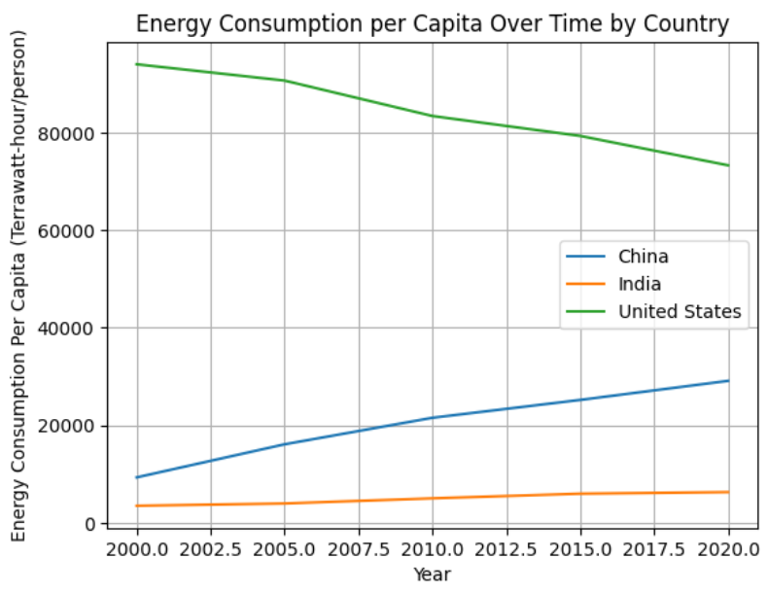

*(Energy Consumption per capita of China, Indian, United states from 2000 - 2020)*

[Source Code](https://colab.research.google.com/drive/1Y7j_fSDdQffmfBSyPKN9HAQNySUeBVON?usp=sharing)

### **Energy Production from Renewable vs Non-Renewable Sources Trends**

To look at impact from a different angle, we can also look at renewable vs non-renewable sources trends. The share of energy produced from renewable sources has grown significantly in all three countries, albeit at different rates.

In the United States, renewable energy, particularly wind and solar, has experienced significant growth, driven by federal and state-level policies that incentivize clean energy investments through tax credits, subsidies, and renewable portfolio standards. This surge has been further supported by technological advancements that have lowered costs and improved efficiency, making renewables increasingly competitive with traditional energy sources. The growth of wind energy, especially in regions like the Midwest, and solar power, particularly in states like California and Texas, has contributed to a steady decline in coal use as utilities transition to cleaner, more sustainable options. This shift has not only reduced greenhouse gas emissions but also diversified the U.S. energy mix, underscoring the country’s progress toward a cleaner energy future.

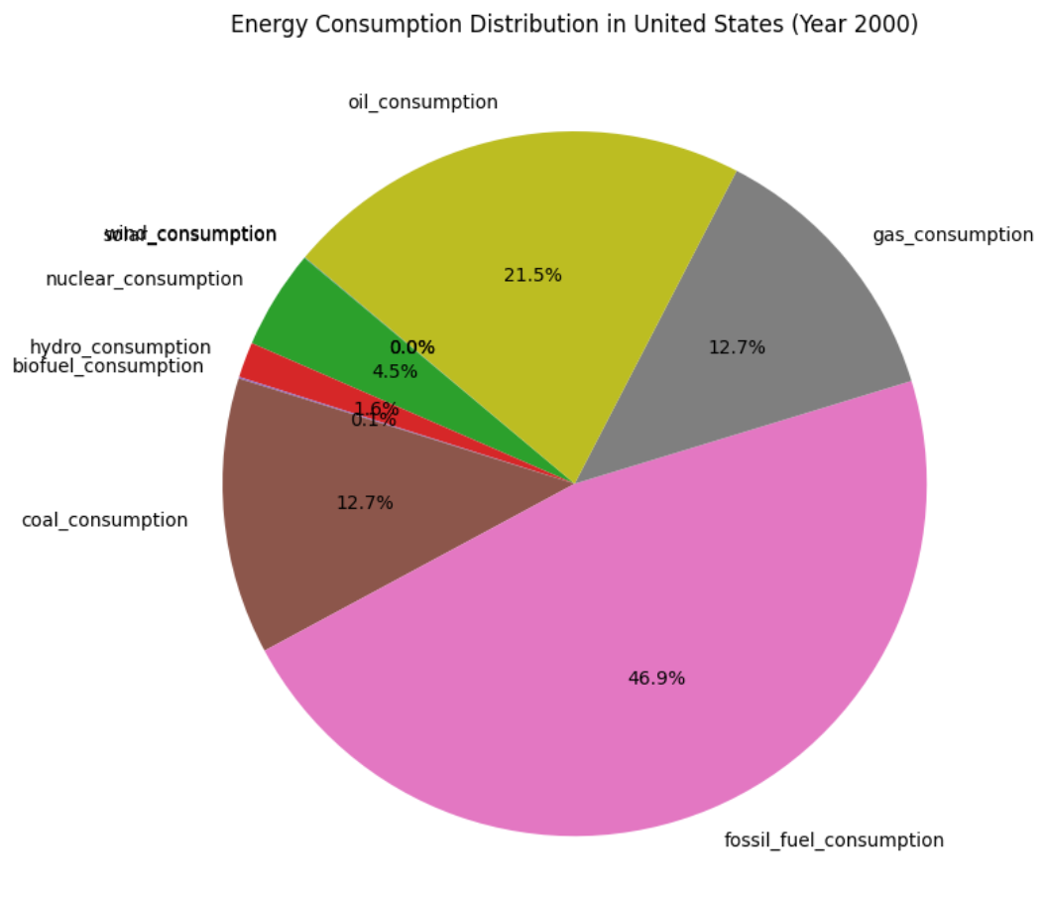

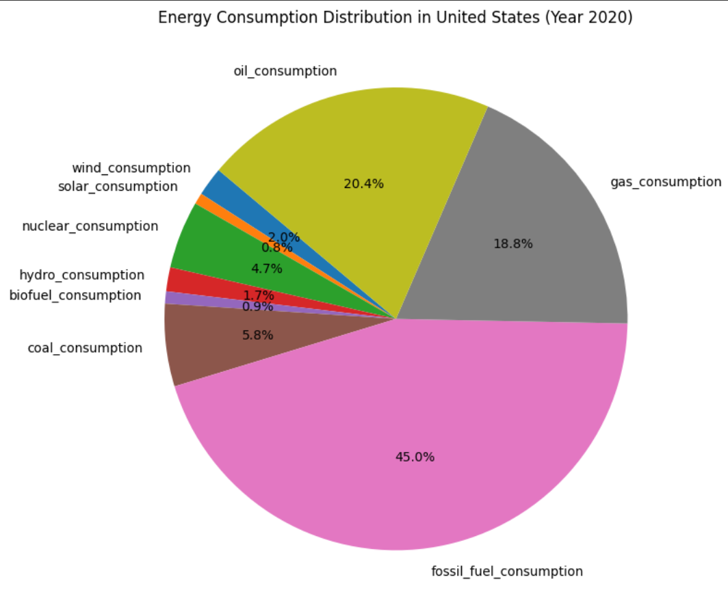

*(Energy Consumption Distribution in United States 2000 vs 2020)*

China has made remarkable strides in renewable energy production, becoming the global leader in both solar and wind energy generation, with massive solar farms in regions like Qinghai and the Gobi Desert and expansive wind farms both onshore and offshore. Its dominance in manufacturing photovoltaic panels has driven down global solar energy costs, while investments in large-scale wind projects and advanced turbine technology highlights its commitment to clean energy. Additionally, China leads the world in hydropower production, with projects like the Three Gorges Dam playing a significant role in its energy mix. However, coal still dominates China’s energy consumption due to its abundant reserves, affordability, and ability to provide stable baseload energy, which is crucial for the country’s growing economy. Despite this reliance, China’s ambitious climate goals—peaking carbon emissions by 2030 and achieving carbon neutrality by 2060—have spurred massive investments in renewable energy infrastructure, energy storage, and grid modernization. By balancing its energy needs with sustainability, China is not only transforming its energy landscape but also contributing significantly to global climate action by exporting renewable energy technologies and expertise.

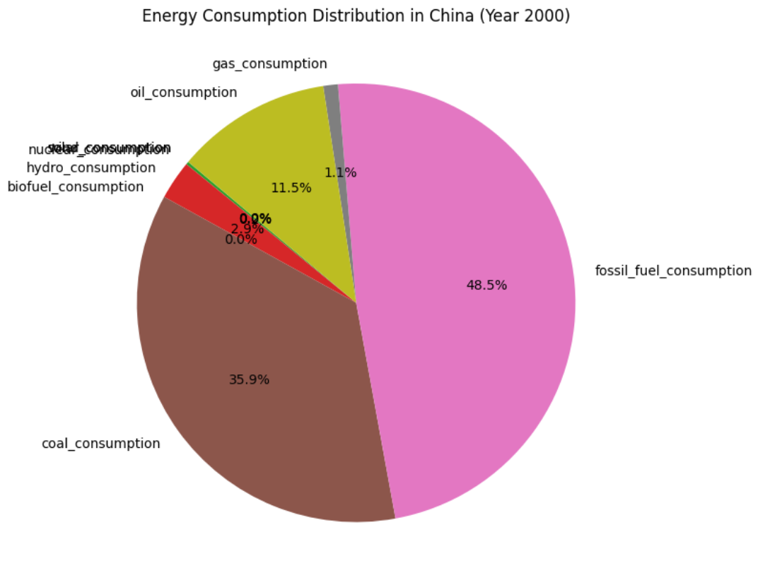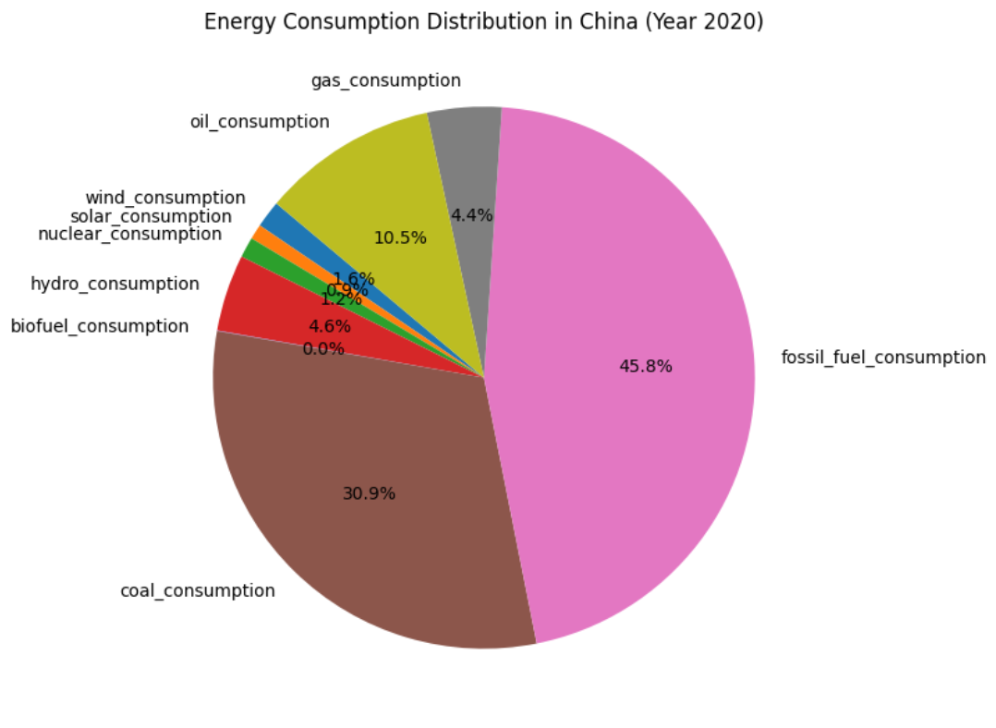

*(Energy Consumption Distribution in China 2000 vs 2020)*

India, while emerging as a global leader in solar energy development with vast solar farms like the Bhadla Solar Park and ambitious initiatives under the National Solar Mission, continues to rely heavily on coal for electricity generation, which remains the backbone of its energy system due to its affordability and domestic availability. However, the share of renewables in India’s energy mix is rapidly increasing, driven by government policies, international investments, and a commitment to achieving 500 GW of non-fossil fuel capacity by 2030. This transition is complemented by significant growth in wind energy and hydropower, highlighting India’s efforts to balance its energy demands with sustainability goals while addressing the challenges of energy security and climate change.

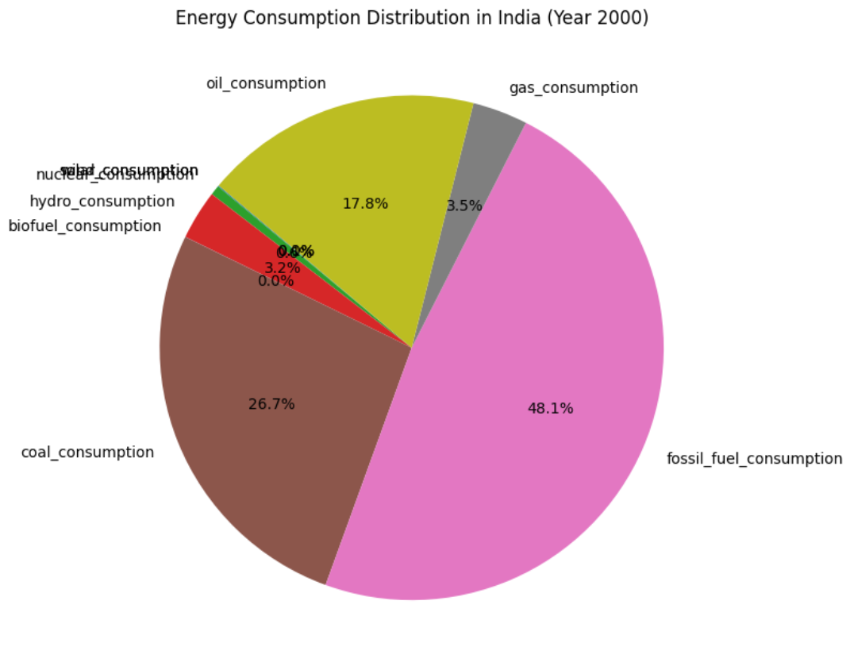

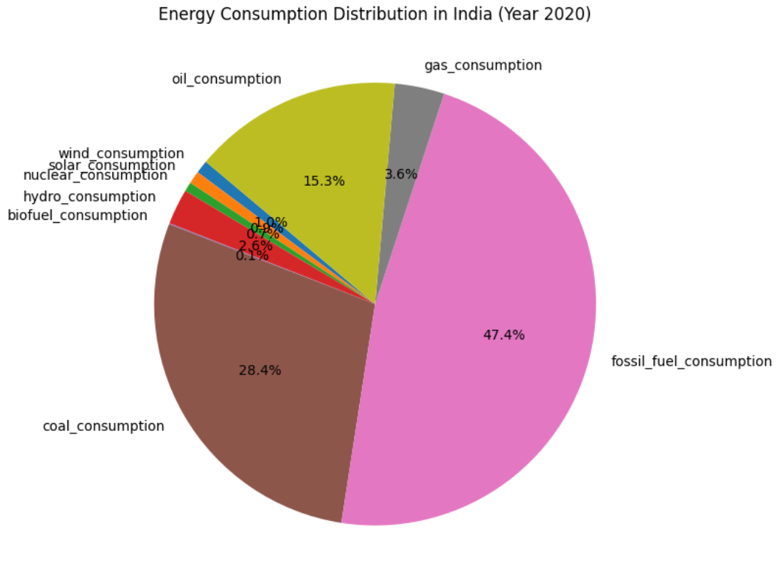

*(Energy Consumption Distribution in India 2000 vs 2020)*

[*Source Code*](https://colab.research.google.com/drive/1wV0jtz2stjupMUYFUbOVWyEkIrSQxa2A?usp=sharing)

**Energy Consumption and Economic Growth**

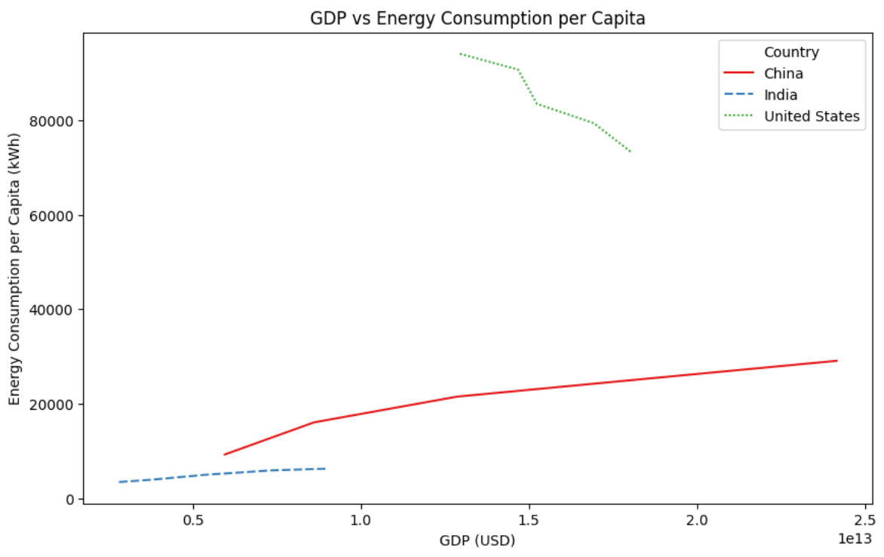

[Source Code](https://colab.research.google.com/drive/1a6vPCRp1-NkdhFRzzqSRyH863SQyowR_?usp=sharing)

The relationship between energy consumption and economic growth varies significantly among China, India, and the United States, reflecting their distinct stages of development and energy policies. In China, rapid economic expansion over the past two decades has been closely tied to a surge in energy consumption, primarily fueled by coal. Industrial growth and infrastructure development have driven this demand, making energy consumption a central driver of China’s economic growth. In India, while economic growth has also spurred an increase in energy consumption, the country’s per capita energy use remains relatively low compared to China and the U.S., reflecting its still-developing industrial base and reliance on traditional energy sources in rural areas. Nevertheless, as India urbanizes and industrializes, its energy consumption is steadily rising. In contrast, the U.S. exhibits a more decoupled relationship between energy consumption and economic growth. Over the past two decades, economic output has grown, but energy consumption per capita has stabilized or declined due to improvements in energy efficiency, technological advancements, and a shift toward a service-based economy. This decoupling suggests that economic growth can be sustained without proportionally increasing energy use, a trend that China and India are beginning to explore as they invest in renewable energy and energy efficiency measures.

**Moving Forward**

To reduce the environmental impact of energy consumption and GHG emissions, a multipronged approach is essential, involving technological innovation, policy implementation, and behavioral change. Governments must accelerate the transition to renewable energy sources by investing in solar, wind, and hydropower infrastructure and phasing out subsidies for fossil fuels. Enhancing energy efficiency across all sectors—transportation, residential, commercial,industrial,etc—can significantly lower emissions while maintaining economic productivity. Electrification of transportation, combined with an expansion of charging infrastructure and incentives for electric vehicles, will play a crucial role in reducing dependence on fossil fuels. Urban planning must prioritize public transit and energy-efficient buildings to decrease per capita energy use. Policies such as carbon pricing, stricter emissions standards, and support for research and development in clean energy technologies can drive systemic change. On an individual level, reducing energy consumption through conservation efforts, adopting renewable-powered appliances, and making sustainable choices in transportation and consumption are critical. Globally, fostering international collaboration to share technology and expertise can help developing nations leapfrog to cleaner energy systems, ensuring equitable progress toward a low-carbon future. By integrating these strategies, the world can align economic growth with environmental sustainability and meet climate goals.

**Sources**

U.S. Energy Information Administration. *International Energy Statistics*. <https://www.eia.gov/international/data/world>

International Energy Agency. *Emissions Intensity and Energy Efficiency Indicators*. <https://www.iea.org/reports/energy-efficiency>

U.S. Energy Information Administration. *Energy Consumption by Sector*. <https://www.eia.gov/consumption/>

Ali, K. (2024, October 18). *Energy consumption dataset by our world in Data*. Kaggle. <https://www.kaggle.com/datasets/whisperingkahuna/energy-consumption-dataset-by-our-world-in-data>

Shahane, S. (2021, July 8). *Green House Gas Historical Emission Data*. Kaggle. <https://www.kaggle.com/datasets/saurabhshahane/green-house-gas-historical-emission-data>

U.S. Department of Commerce. *India—Renewable energy*. Retrieved from <https://www.trade.gov/country-commercial-guides/india-renewable-energy>

**Source Code**

[Project folder with all code](https://drive.google.com/drive/folders/1QYVi3OZXnur-D8Jj1CFqnQgxE58on7nD?usp=drive_link)